Artificial Intelligence Behavior Brief

Documentation for My Brief

This is a template to help guide you on writing the brief for your Artificial Intelligence Behavior. Feel free to edit and modify this as you choose as long as it meets the requirements laid forth in the rubric as defined on Canvas and the Subject and Assessment Guide.

Each section will contain a brief passage of text that describes what you should expect to write. Please remove these passages before submitting your brief for review.

You may amend your brief throughout the subject where necessary with discussion with your instructor.

# Behavior Overview

My goal is to make some kind of stealth game making a behavior system for patrolling enemies will be needed for my goal. Enemies will switch from patrol, seek, and attack states.

## Pathfinding Solution

NavMesh will be used for Pathfinding. Used to get to one waypoint from another or to follow player.

## Decision Making Solution

Finite State Machines will be used for decision making.

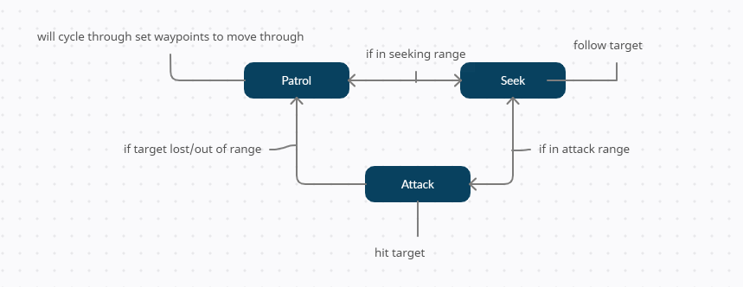

# Third Party Graphical Framework

This section discusses the third-party graphical framework that will be used.

## Suitability

- <https://www.kenney.nl/>

-Unity

## Technical Impact

-Kenny assets will be used for object looks/Rendering Materials

-Unity for creating and making my project

## Licensing

# Kenny: This content is free to use in personal, educational and commercial projects.

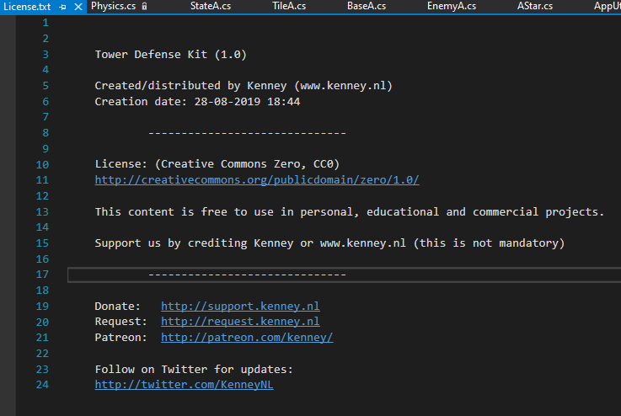

Unity: Student license <https://unity3d.com/legal/terms-of-service/software>

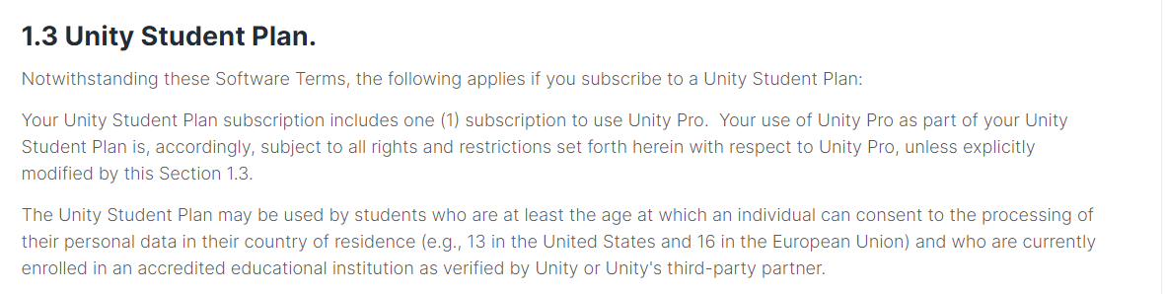

Underlying Mathematical Operations and Algorithms

## Mathematical Operations

Please list and explain the reason for any notable **mathematical operations** that your brief will need to undertake. The use of vector math alone is not notable – it is very common in game development to make use of vectors.

For example, it is notable and worth mentioning that your project will calculation *barycentric coordinates* to create a software renderer that will interpolate values for use in its fragment shader stage.

Not sure

## Advanced Algorithms

I will use Steering Behaviors to Move my objects from one point to another.

# Research Material

[Navigation Meshes (sharepoint.com)](https://myaie.sharepoint.com/sites/msteams_473172/SitePages/Navigation-Meshes.aspx)

[A* (A-Star) Algorithm (sharepoint.com)](https://myaie.sharepoint.com/sites/msteams_473172/SitePages/A-.aspx)

[Artificial Intelligence for Games (sharepoint.com)](https://myaie.sharepoint.com/sites/msteams_473172/SitePages/Artificial-Intelligence-for-Games.aspx)

[Finite State Machines (sharepoint.com)](https://myaie.sharepoint.com/sites/msteams_473172/SitePages/Finite-State-Machines.aspx)

<https://github.com/AIE-Seattle-Prog/ArtificialIntelligenceForGamesDemos>

# Technical Risks

If there any risks or further considerations that provide cause for concern, please list them here.

Not sure

# Credits

Trey Gleason © 2021